**Experiment No. 1**

**Title:**

Sketch out and analyze architecture of Moodle cloud portal and moodle cloud site and create different entities dynamically.

**Objective:**

To learn Software as service using Free trial of Moodle cloud

**Tools used:**

Internet , Moodle cloud service

**Prerequisite:**

Understanding of Software as service in Service model of cloud computing

**Theory:**

MoodleCloud is a learning environment that is hosted in the cloud. For everyone who requires an online learning environment to conduct a class or promote learning in any setting, including instructors, trainers, and students, MoodleCloud is a good solution.

Since it is in the cloud, as its name suggests, there is no need to download it. As a result, MoodleCloud makes creating your own Moodle site very quick, with little guesswork. It is the hosting system for Moodle, created and managed by the Moodle developers. MoodleCloud is a ready-to-use LMS solution that includes the most popular Moodle functionalities.

After a short and simple setup process, you can start your road toward e-learning distribution with this free or inexpensive hosting solution for a straightforward but fully working Moodle site.

Moodle Cloud is designed for organizations that want to understand what a Moodle site can offer because of its focus on simplicity and speed. It is a straightforward answer. Moodle Cloud should get you up and running if you have fewer users and merely want to quickly and easily provide basic e-learning content to your learners. However, it offers less flexibility that having a self-hosted platform.

**Step 1. - Creating Account For moodle cloud service**

[**https://moodle.com/solutions/moodlecloud/**](https://moodle.com/solutions/moodlecloud/)

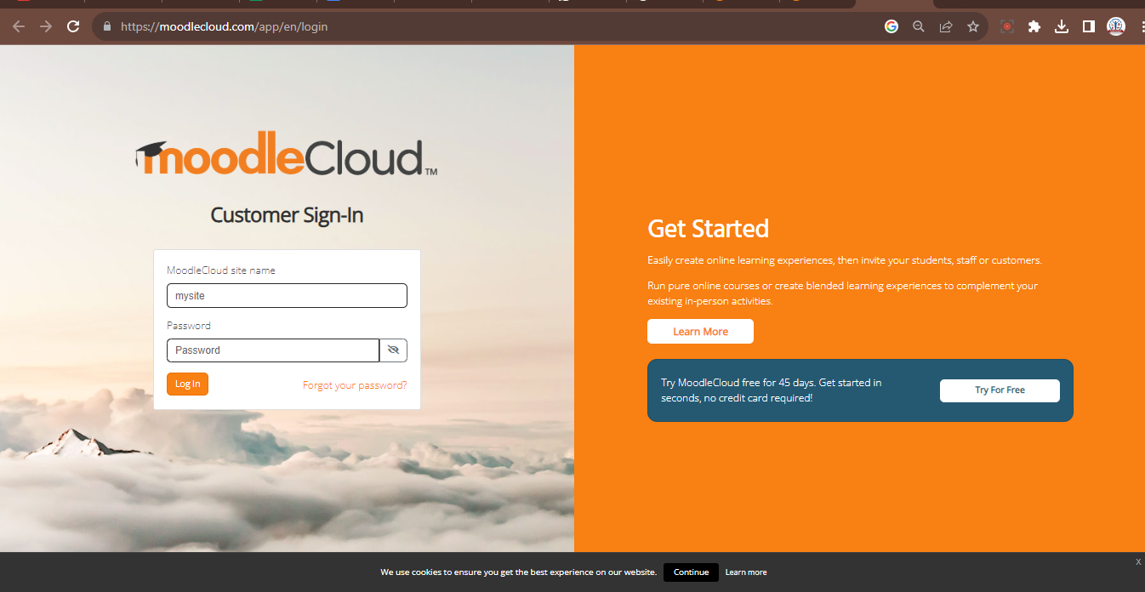

**Step 1. – Enter your details**

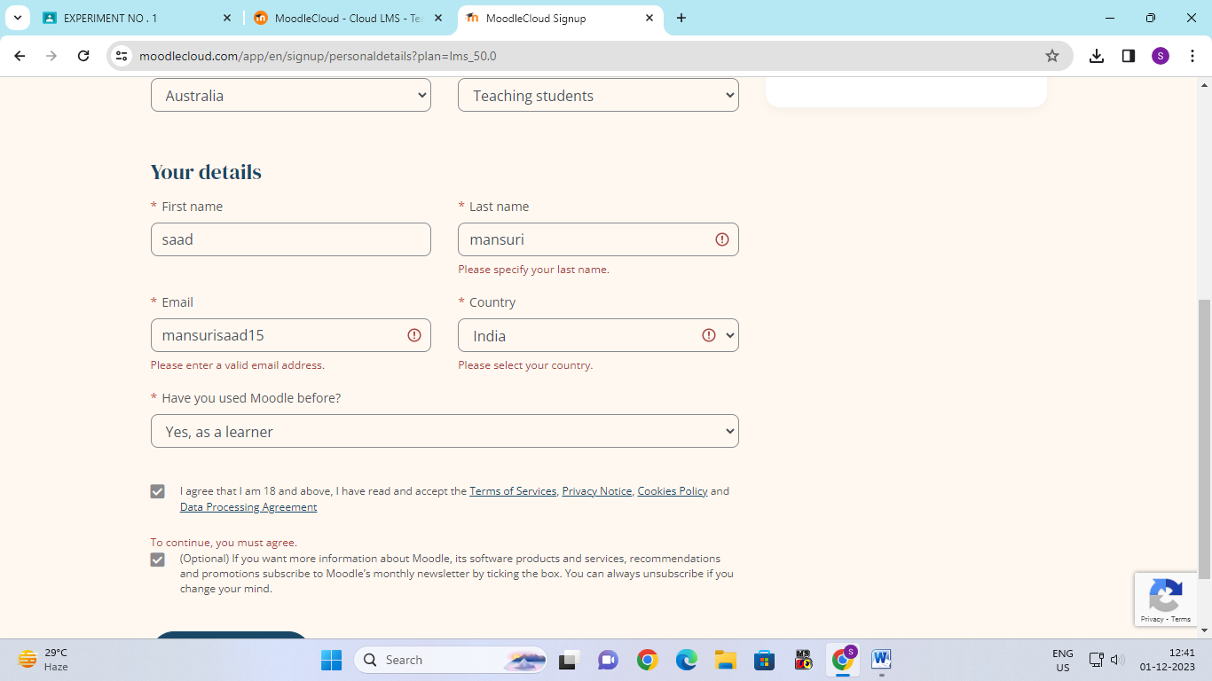

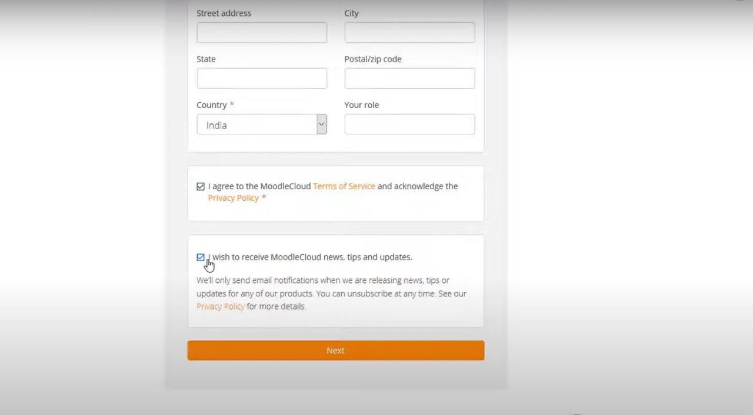

**Step 3 - Secure Account by creating password**

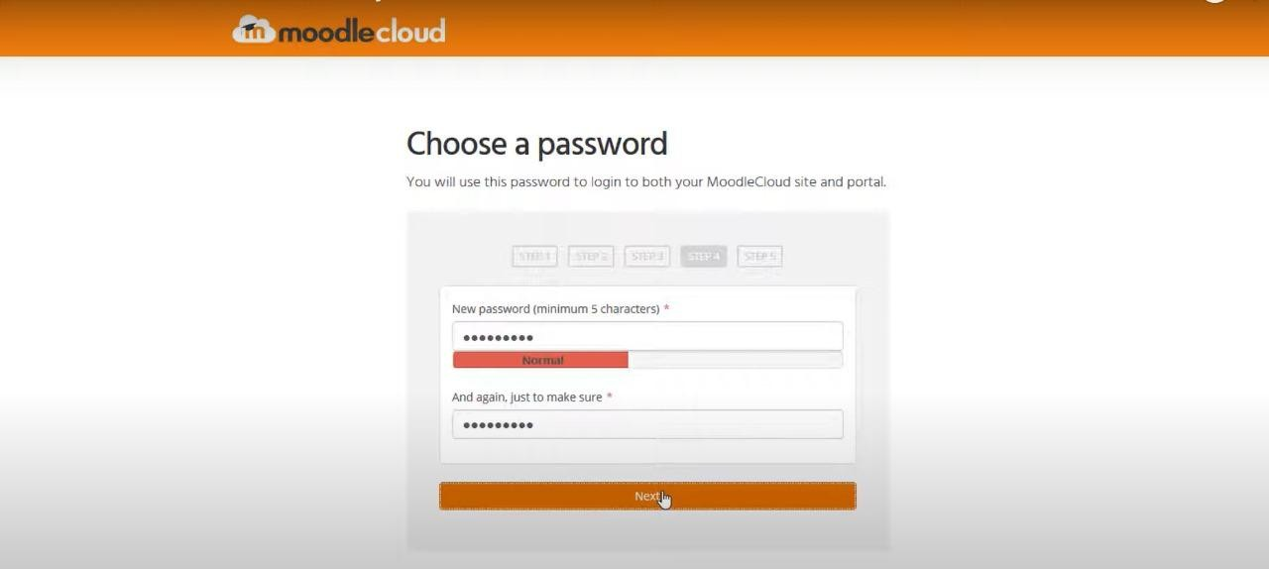

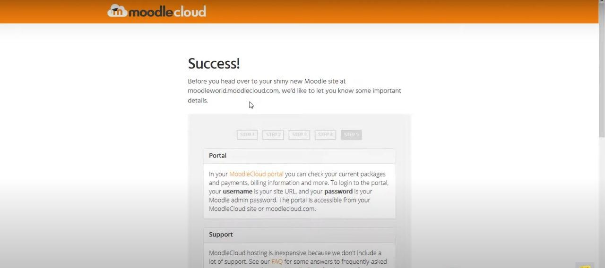

**Step 4 - select country & specific domain name of site**

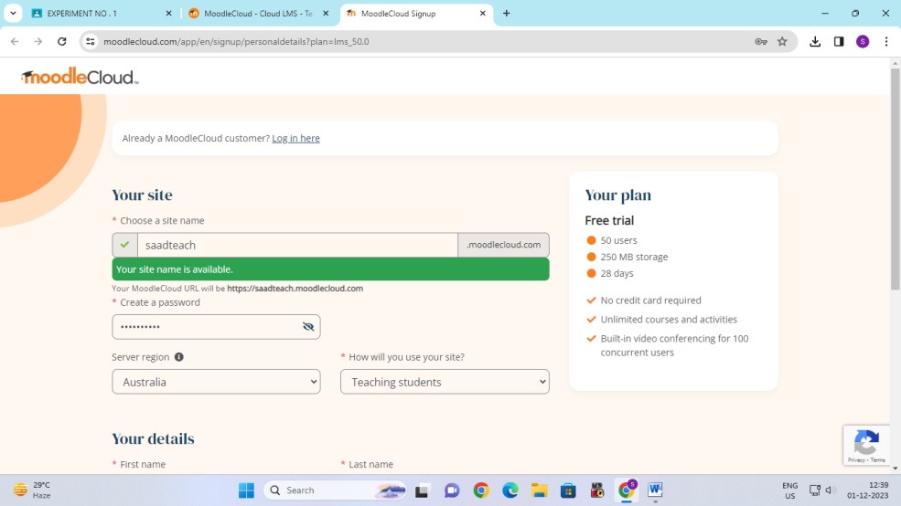

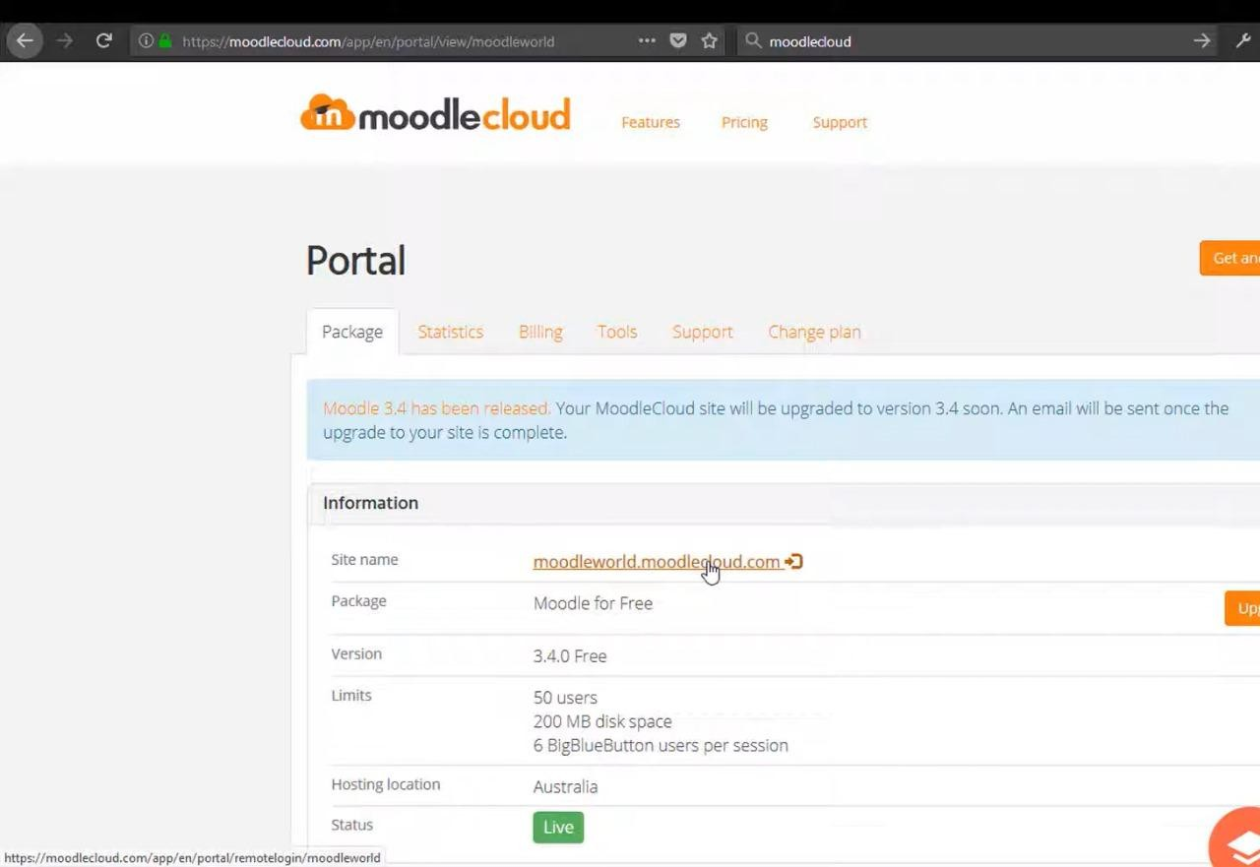

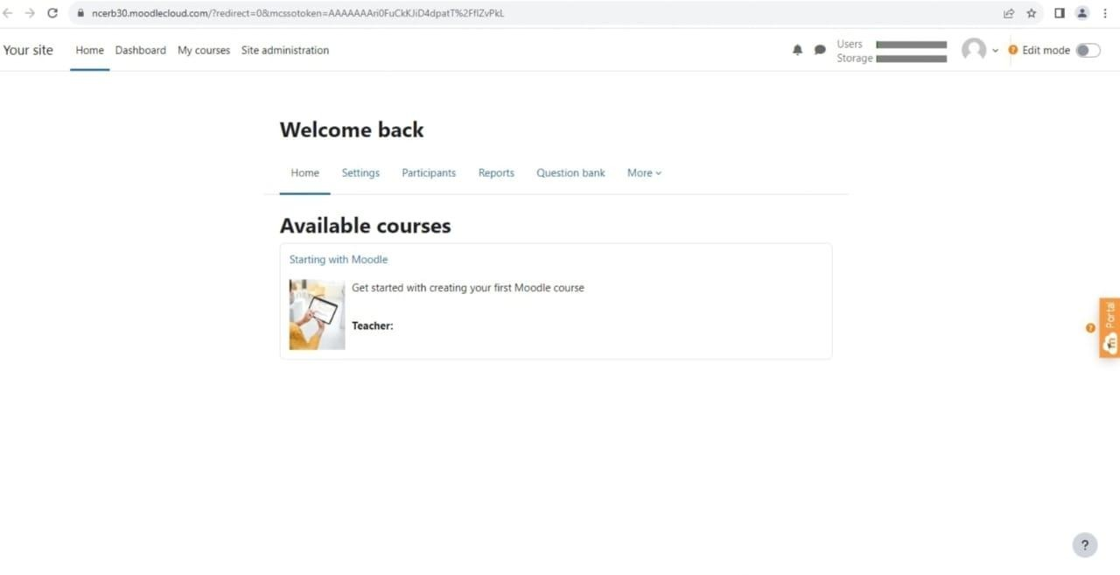

**STEP 6-Successflully created and uploaded courses in moodle cloud.**

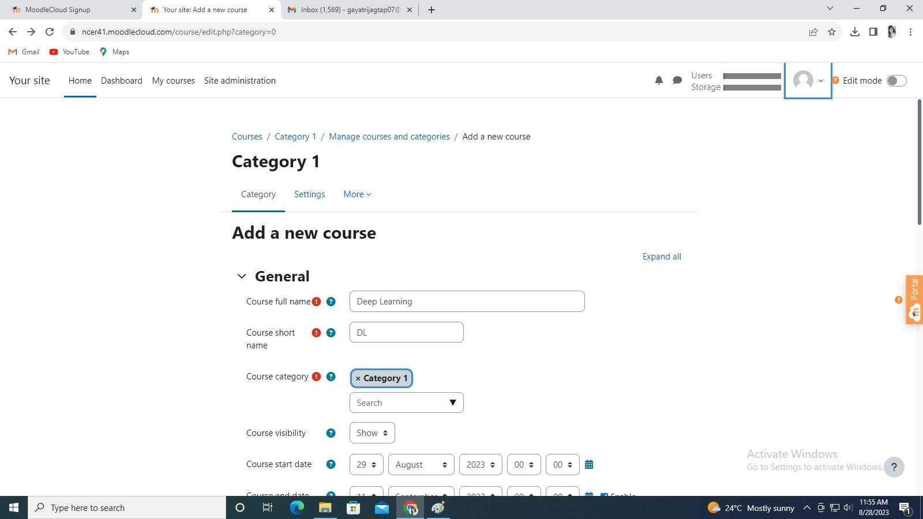

Here onward you have to register your website and add users and courses to it

The courses will be available to registered users having username and password throughout the qlobe

For next 45 days trail period , if you like to continue you have pay as per your usage i.e no of users and space utilised by you to the courses material.